|  |  |
| --- | --- |
| NUIM_logo (Hi-Quality) | **National University of Ireland, Maynooth** Department of Electronic Engineering  EE204: Analog Electronics |

## Title: The FET Amplifier

## Number: 4

**EQUIPMENT**

Power supplies

Voltmeter/Ammeter

ZVN NMOS

Breadboard

Three co-ax connectors

**OBJECTIVE**

The purpose of this experiment is to understand the function of the MOSFET Transistor and how it performs as an amplifier. In this experiment we will build a simple low gain amplifier. We will examine its low frequency and high frequency performance. We will then modify the design to double its gain and then re-examine the high frequency performance.

PROCEDURE

Construct the following circuit.

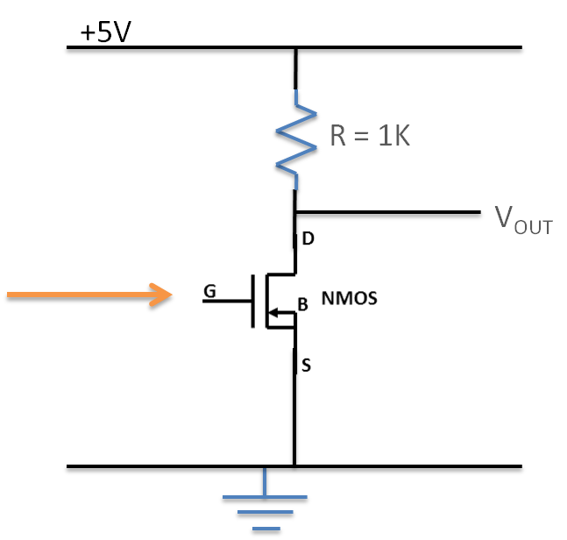

The resistor is 1 kΩ and the power supply is 5V.

The signal generator will be providing the input signal. It should be set to provide an input signal of mean value 2 Volts and a 200mV peak-to-peak signal of frequency 10 kHz. You may need to adjust this mean value to get the transistor to work as every transistor is slightly different. Therefore you should adjust it until the output is about 2.5 volts average value.

Observe the output VOUT at the drain of the NMOS using an oscilloscope. There should be an output signal of the same frequency as the input. Observe and write in your report the mean value of the signal and the output peak-to-peak amplitude for this frequency. Using two cables, observe simultaneously the input and output signals. Include a sketch in your report. Is there anything else that can be observed other that frequency and amplitude of the signals?

**Part 2:**

Given the above circuit, identify the peak-to-peak amplitude voltage for different values of input signal frequency. Generate a table and graph the amplification (gain) achieved for frequencies ranging from 1 kHz to 10 MHz in steps of 10. Using the buttons on the signal generator should help you do this quickly.

**Part 3:**

Return the input frequency to the original settings for part 1. In this case, replace the 1K resistor with a 3.3K resistor. Comment on any change in the output signal. Does the change make sense… why?

**Part 4:**

In Part 1, you found an average DC value voltage for the input signal that got a VOUT in the range of 2.5 volts (ish). In this section, you will be using RB1 and RB2 to recreate this voltage.

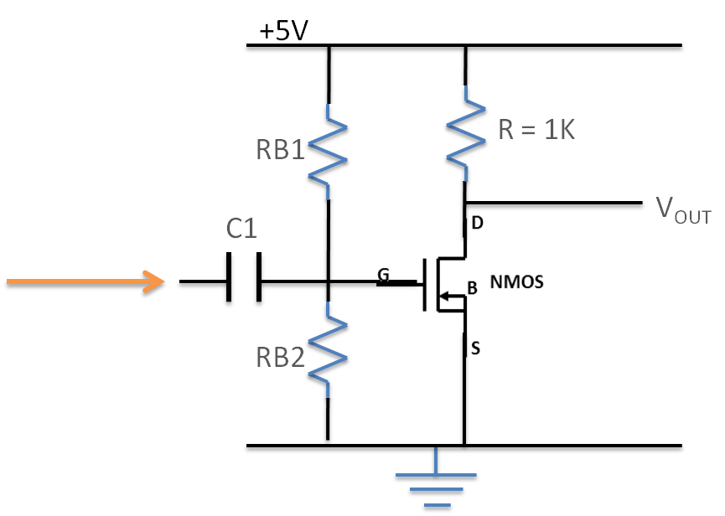

Verify that you get an DC output voltage that is between 2 and 3 volts. Adjust your resistors as necessary to get the right value.

Add a capacitor of value 10 uF.

Connect to the capacitor a 10 kHz 200mV signal from the signal generator that has no DC offset (zero mean).

Observe the output. If everything is working perfectly it should replicate the results from part 1. If it does not, try to identify where it is not working. Report the results of your investigation. Everything is a valid response.

### REQUIRED RESULTS IN REPORT

* A brief introduction showing you know what the lab is about (3-4 lines MAX)
* For each section you need the following
  + - A drawing of the circuits used
    - Your results, including sketches or photographs of waveforms
    - Answer all questions asked
    - Comments and opinions on results or methods used
* Conclude your report with a summary section which may include any additional conclusions you may have.

|  |
| --- |
| **Marks will be deducted for poorly presentation, poorly written reports.**  **Marks will only be awarded for sections completed.** |